

Cinema Program Project
Owen Nathanael
C00313648

Description
: This is a Program used by the user to order tickets through the program. You have the options to order food through the program which will be assigned to your account. Purchasing tickets will reward you with loyalty points and these can be used to get discounts for food and drinks.
Table of content
:
Contents
Description 2
Requirements 2
Database 3
Test 8
E-R Diagram 11
Interesting source code snippets 11
Conclusion 14

Requirements
:
Name | Verify unregistered users cant purchase tickets
Requirement | The system requires customers to log in

Name | Verify that unregistered users can browse
Requirement | Users are able to browse the movie options

Name | Verify loyalty points can be spent
Requirement | Customers who are logged in can spend their loyalty points

Name | Verify user reviews work
Requirement | Logged in users are able to post reviews for movies

Name | Verify customer service system functionality
Requirement | Logged in users are able to access customer service

Name | Verify successful ticket order
Requirement | Customers must be able to order/pre-order tickets. The customer can order a ticket for the movie and seat they want. And is shown in My Ticket and profile

Database
Customer service:
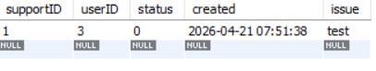
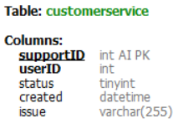

Movie
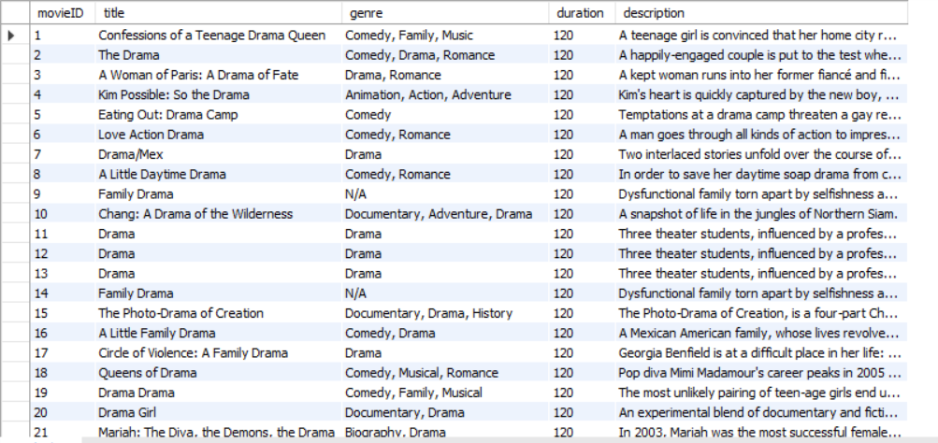
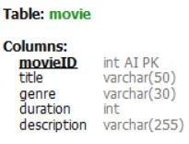
Purchase
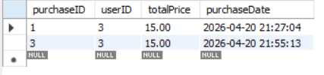
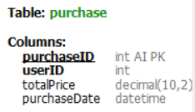

Review
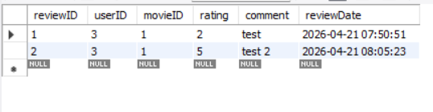
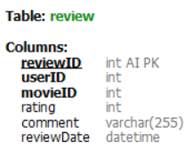

Screening
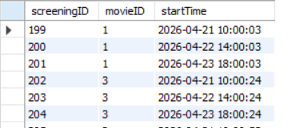
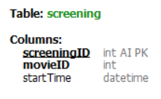
Seat
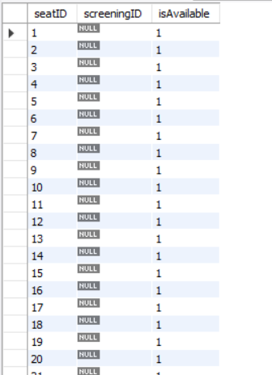
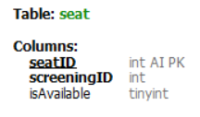
Ticket
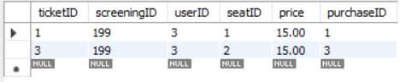
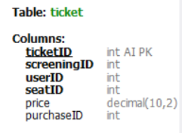

Users
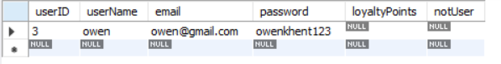
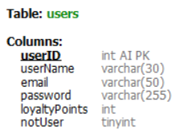

Test
: Login Validation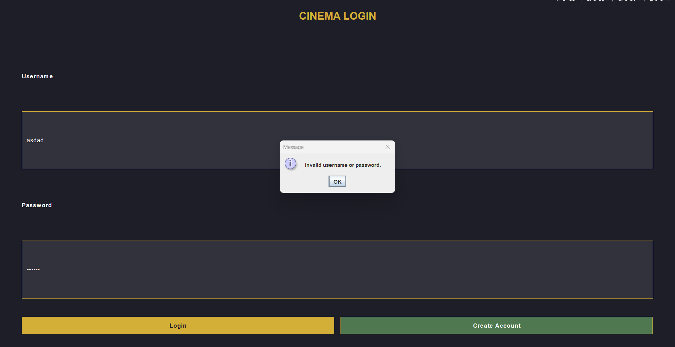
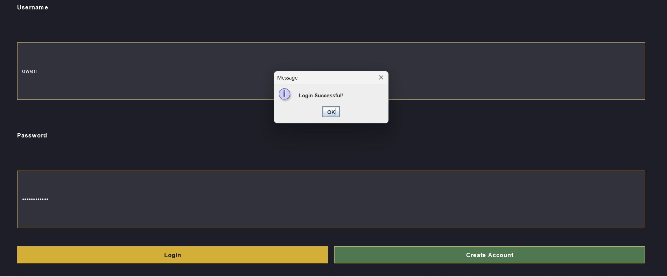

Review Validation
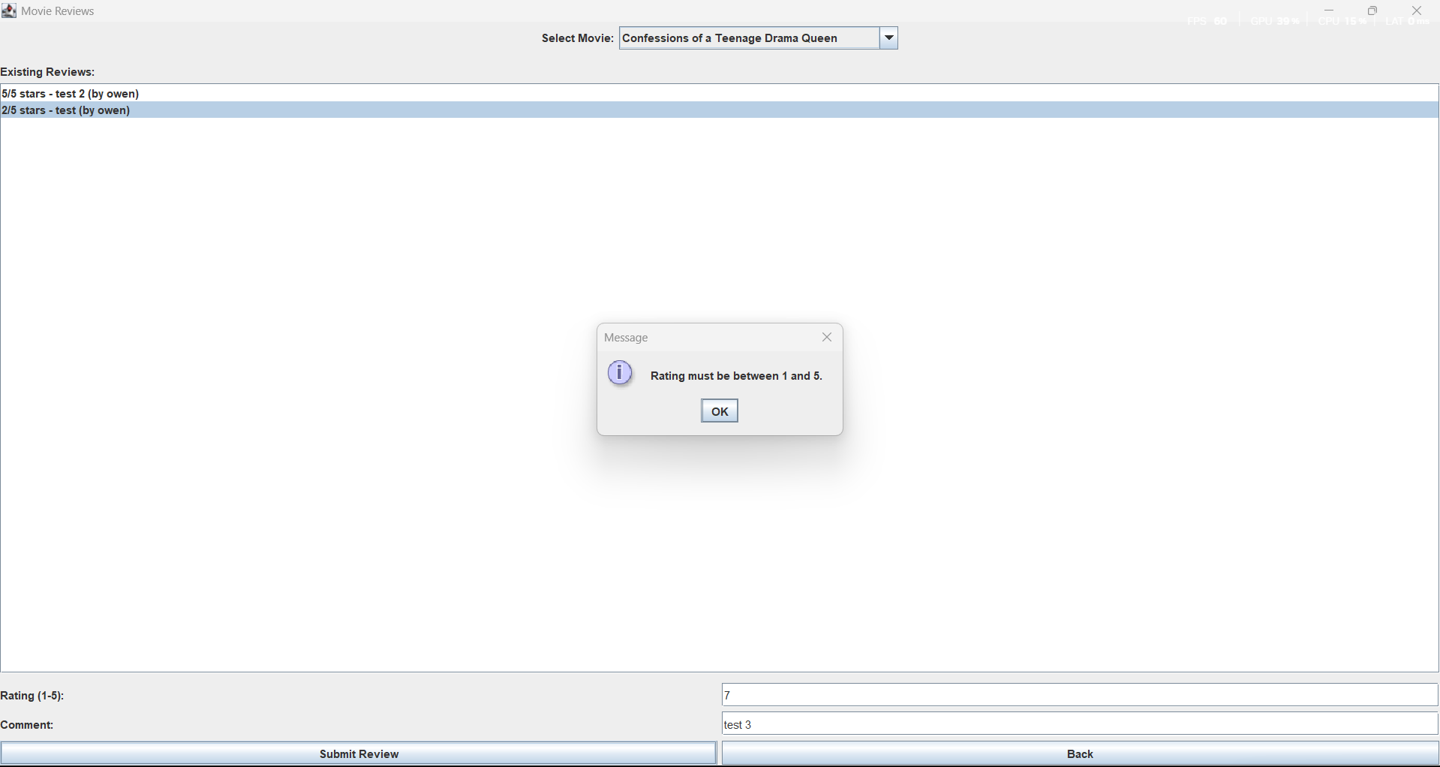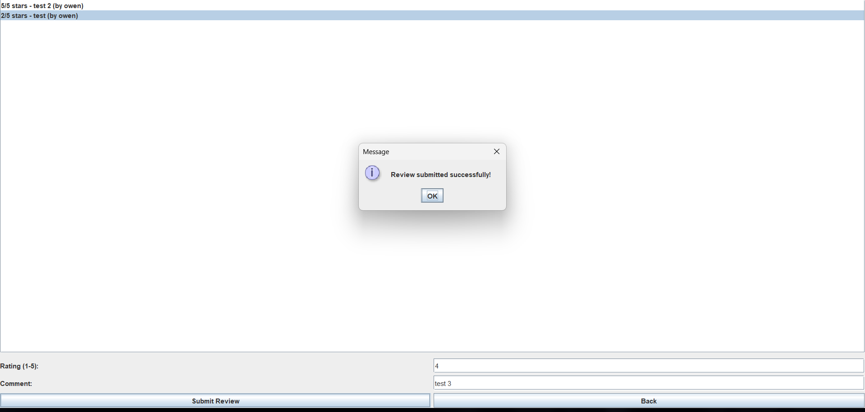

Proof of seat lockout
Seats for teenage drama queen seats 1 and 2 are taken for this screen date
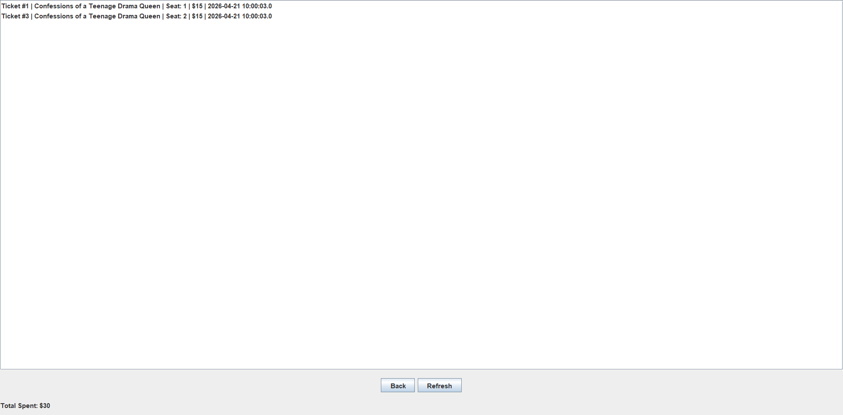
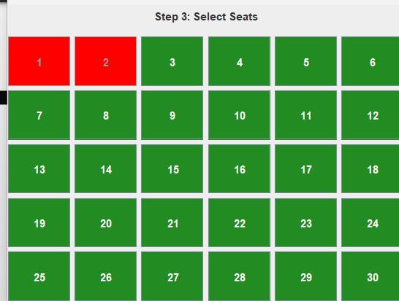

E-R Diagram
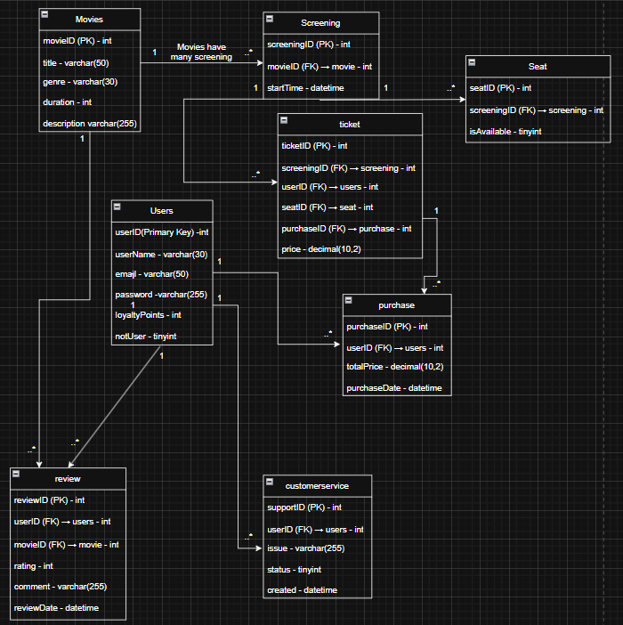

Interesting source code snippets
: setExtendedState(JFrame.MAXIMIZED_BOTH);
This is used to make sure the program launches in maximize form
Example:
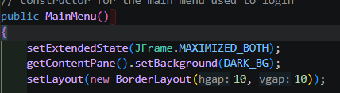
I also used external APIs to get my movies (first time doing this)
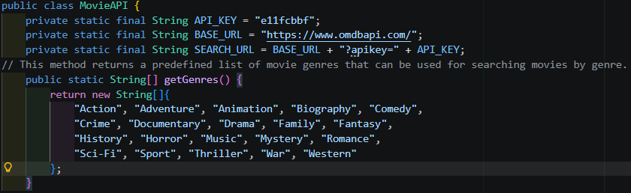
The API key should be given by the API owner, I used OMDB which I then searched for movies by their genre, I also have predefined list of strings that I use to get the genres when searching for them later

I use conn.getInputStream() to call API
BufferedReader reads line by line which is from a library, import java.io.BufferedReader;
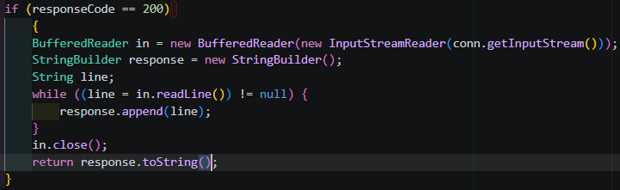

For this I want to specifically talk about .RETURN_GENERATED_KEYS tells the database to give back the auto-generated ID after the INSERT So when you insert a new row, the database automatically generates a unique ID
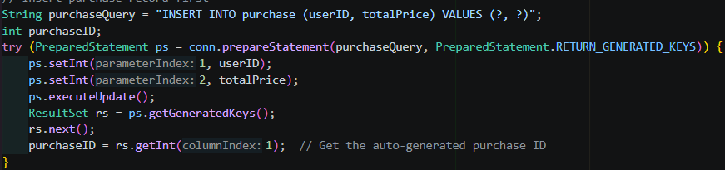
So purchase table auto-increments purchaseID, example, the last purchase was ID 4, after this insert MySQL generates ID 5 and hands it back to your code so you can store it in purchaseID .You'd then use that purchaseID to link other records to this purchase — for example linking tickets to this specific purchase.

I used card layout so that it has the ability to stack multiple panels on each other, like here where I used it in the booking ticket process where you go from page to page starting form movie (select a movie) up until you confirm purchase
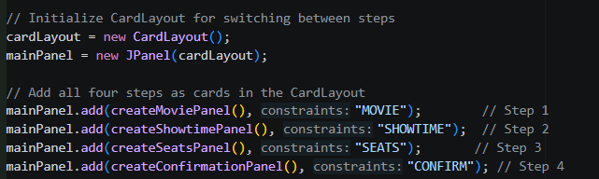

I used this to search my movies through genre by using genre as the keyword for “&s=” (omd handles the matching) and narrow what I pick up from omdb to only things of type movie using &type. I build a URL (SEARCH_URL was defined at the start using a combo of the base url and the key). I also open a connection as seen using the var conn.
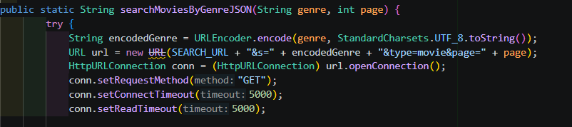

Conclusion
: The features I added to the program works and the tickets, purchases, and the users info like email and username are saved in the profile. The users are able to order tickets for movies with the available screening time and the seats that have been selected can’t be selected again. I’ve learned how to use external APIs for my project so I can get data. I also learned about the different layouts provided by java swing. I also made practical use of exception handling classes. I used URLs (this time connected to the OMDB website which is the API I’m using) .

